**Structure of the web browser:**

The main function of a browser is to present the web resource you choose, by requesting it from the server and displaying it in the browser window. The resource is usually an HTML document, but may also be another type of content (such as PDF, image). The location of the resource is specified by the user using a URI (Uniform Resource Identifier). The way the browser interprets and displays HTML files is specified in the HTML and CSS specifications. These specifications are maintained by the W3C (World Wide Web Consortium) organization, which is the standards organization for the web.

Browser user interfaces have a lot in common with each other. Among the common user interface elements are:

* Address bar for inserting a URI
* Back and forward buttons
* Bookmarking options
* Refresh and stop buttons for refreshing or stopping the loading of current documents
* Home button that takes you to your home page

The browser's main components are:

1. **The user interface**: this includes the address bar, back/forward button, bookmarking menu, etc. Every part of the browser display except the window where you see the requested page.
2. **The browser engine**: marshals’ actions between the UI and the rendering engine.
3. **The rendering engine:** responsible for displaying requested content. For example, if the requested content is HTML, the rendering engine parses HTML and CSS, and displays the parsed content on the screen.
4. **Networking**: for network calls such as HTTP requests, using different implementations for different platform behind a platform-independent interface.
5. **UI backend**: used for drawing basic widgets like combo boxes and windows. This backend exposes a generic interface that is not platform specific. Underneath it uses operating system user interface methods.
6. **JavaScript interpreter**. Used to parse and execute JavaScript code.
7. 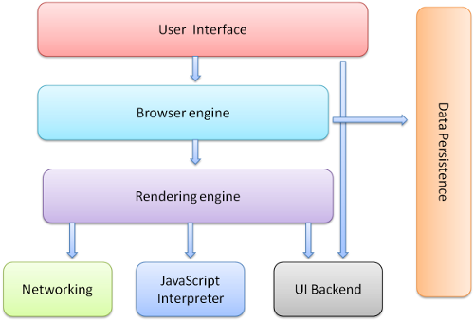**Data storage**. This is a persistence layer. The browser may need to save all sorts of data locally, such as cookies. Browsers also support storage mechanisms such as local Storage, Indexed DB, Web SQL and File System.

**The Rendering Engine:**

The responsibility of the rendering engine is well... Rendering, that is display of the requested contents on the browser screen.

By default, the rendering engine can display HTML and XML documents and images. It can display other types of data via plug-ins or extension; for example, displaying PDF documents using a PDF viewer plug-in. However, in this chapter we will focus on the main use case: displaying HTML and images that are formatted using CSS.